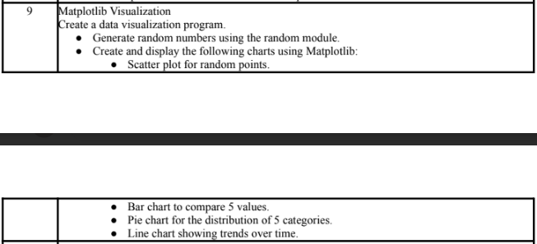
—----------------------------------------------------------------------------------------------------------------------------
COMMAND:
import random
import matplotlib.pyplot as plt

# 1. Scatter Plot
x = [random.randint(1, 50) for _ in range(20)]
y = [random.randint(1, 50) for _ in range(20)]

plt.scatter(x, y, color="blue", marker="o")
plt.title("Scatter Plot of Random Points")
plt.xlabel("X values")
plt.ylabel("Y values")
plt.show()

# 2. Bar Chart
values = [random.randint(10, 100) for _ in range(5)]
categories = ["A", "B", "C", "D", "E"]

plt.bar(categories, values, color="orange")
plt.title("Bar Chart - Comparing 5 Values")
plt.xlabel("Categories")
plt.ylabel("Values")
plt.show()

# 3. Pie Chart
pie_values = [random.randint(10, 50) for _ in range(5)]
labels = ["Cat1", "Cat2", "Cat3", "Cat4", "Cat5"]

plt.pie(pie_values, labels=labels, autopct="%1.1f%%", startangle=140)
plt.title("Pie Chart - Distribution of 5 Categories")
plt.show()

# 4. Line Chart
time = list(range(1, 11)) # time steps (1 to 10)
trends = [random.randint(5, 20) for _ in range(10)]

plt.plot(time, trends, marker="o", linestyle="-", color="green")
plt.title("Line Chart - Trends Over Time")
plt.xlabel("Time")
plt.ylabel("Value")
plt.show()

OUTPUT:
